**Nama : Denda Agus Subagja Kelas : TI.17.D3**

**NIM : 311710178**

1. *- Use Case Diagram*

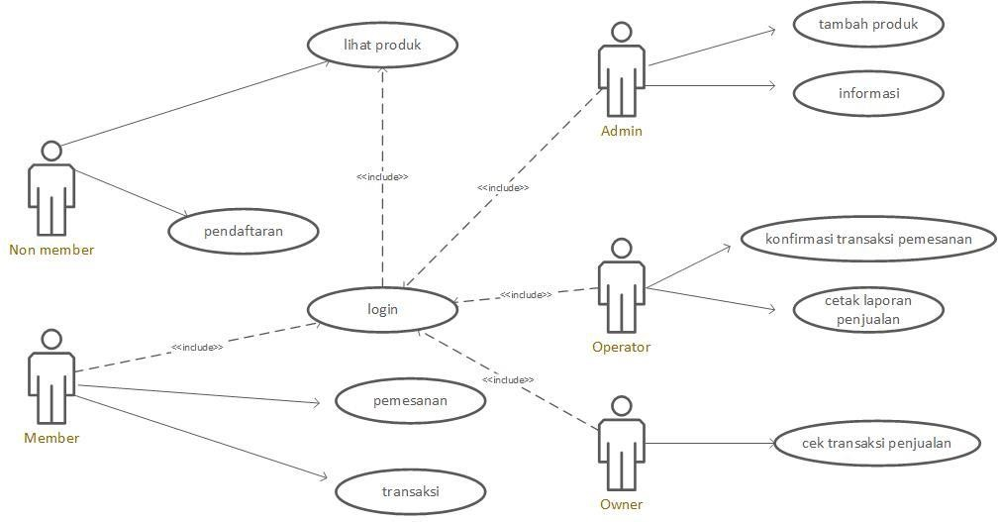

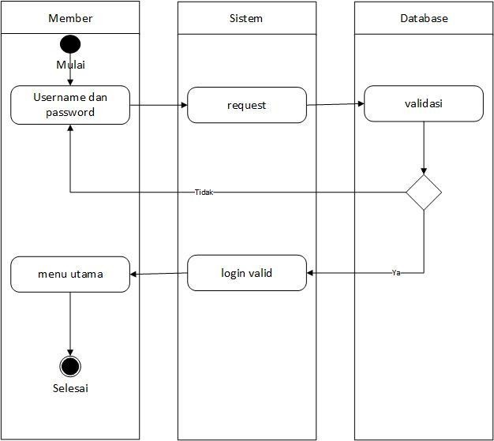

Activity Diagram Login Non Member

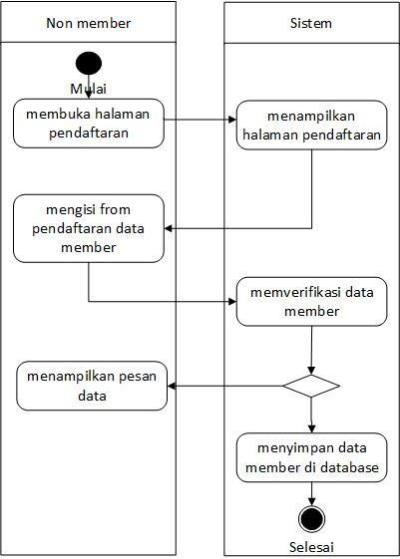

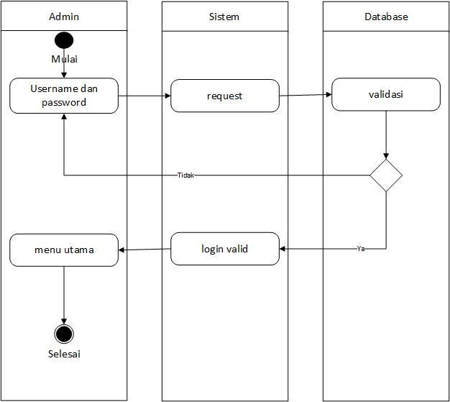

* *Activity Diagram* Login Owner

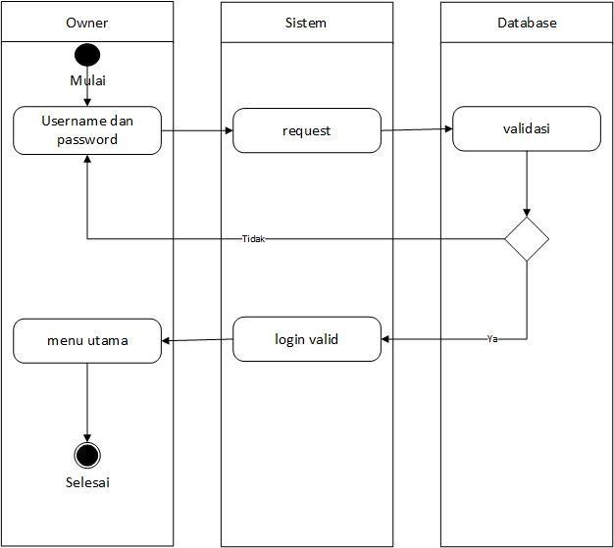

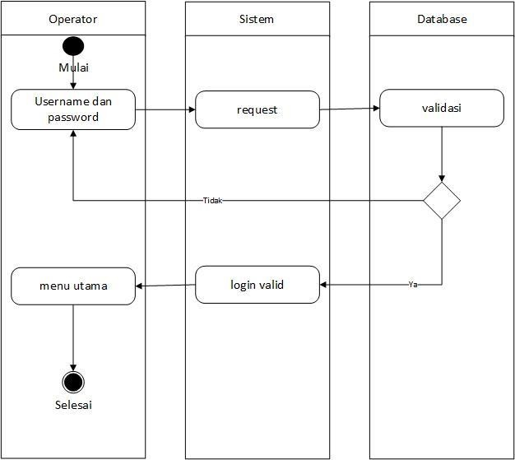

* Activity Diagram Transaksi

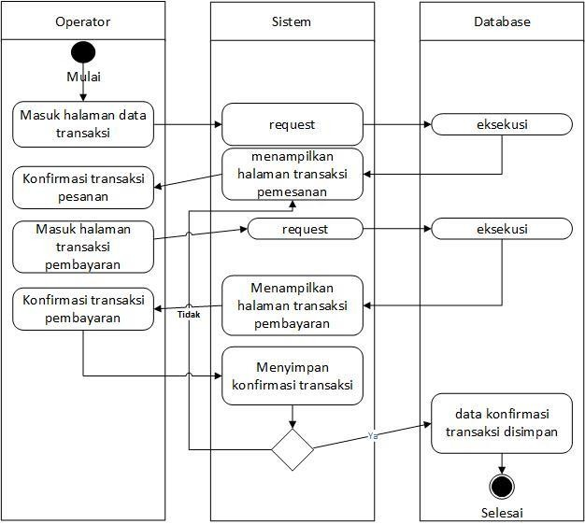

-

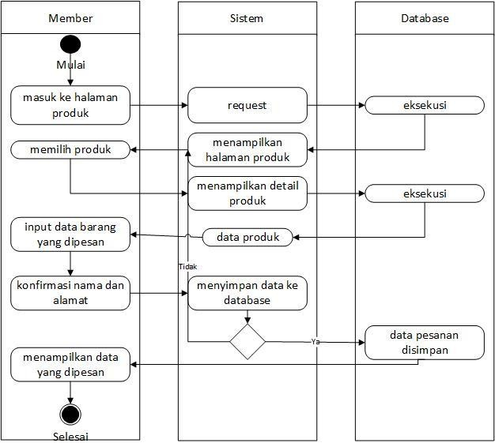

* Activity Diagram Konfirmasi Pemesanan

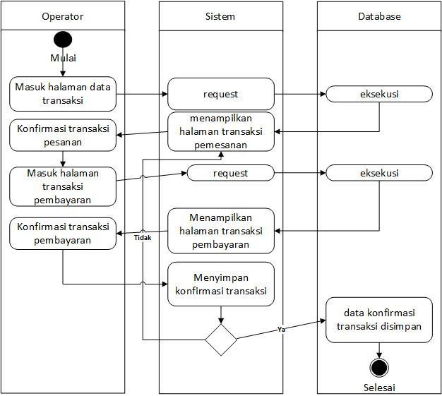

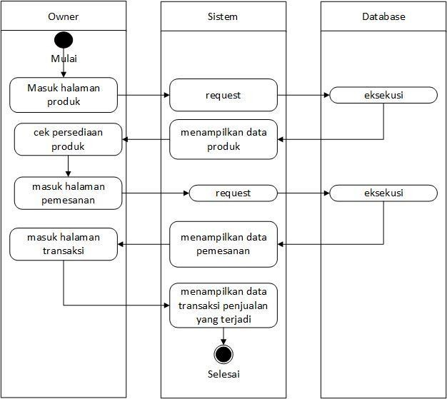

* Activity Diagram Cetak Laporan Penjualan

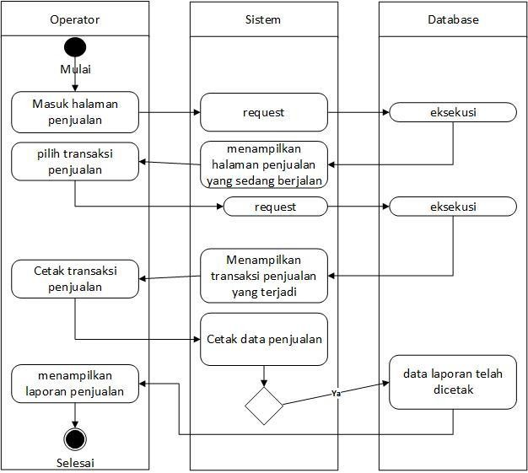

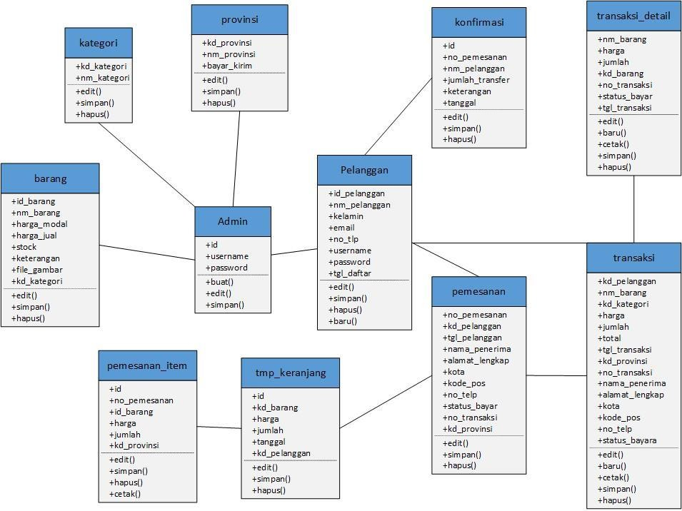

* Sequence Diagram
* Sequence Diagram Login Admin

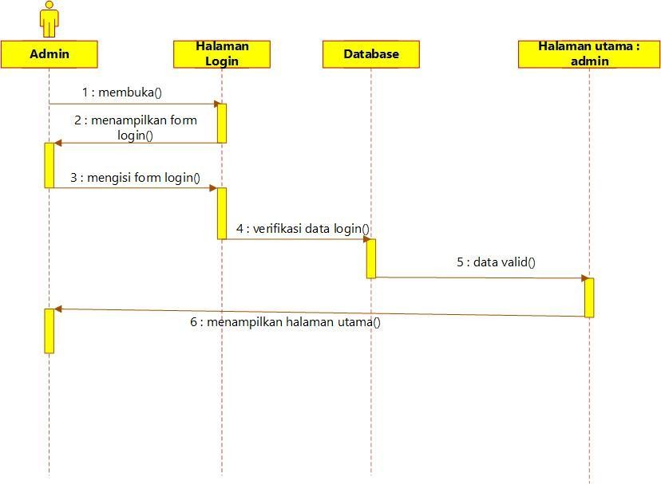

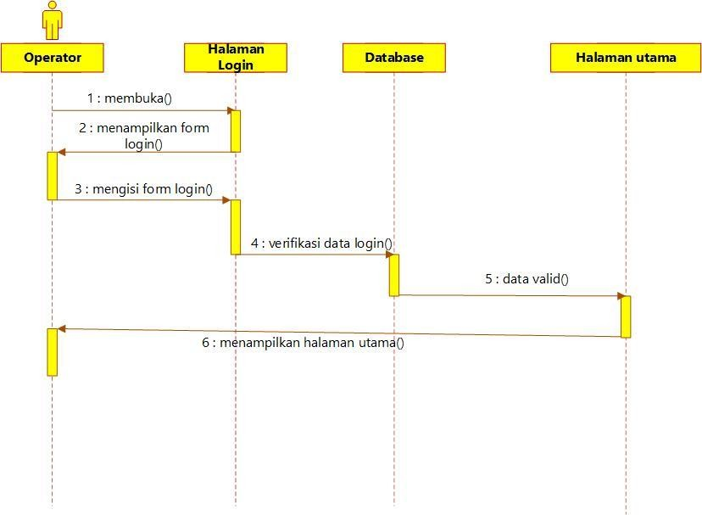

* Sequence Diagram Memesan Produk

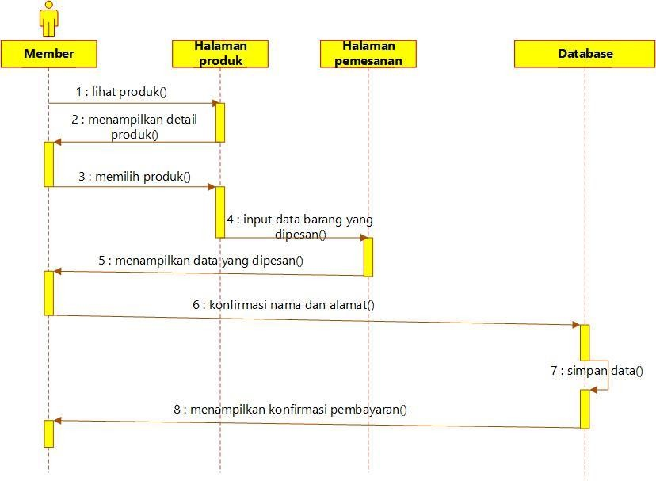

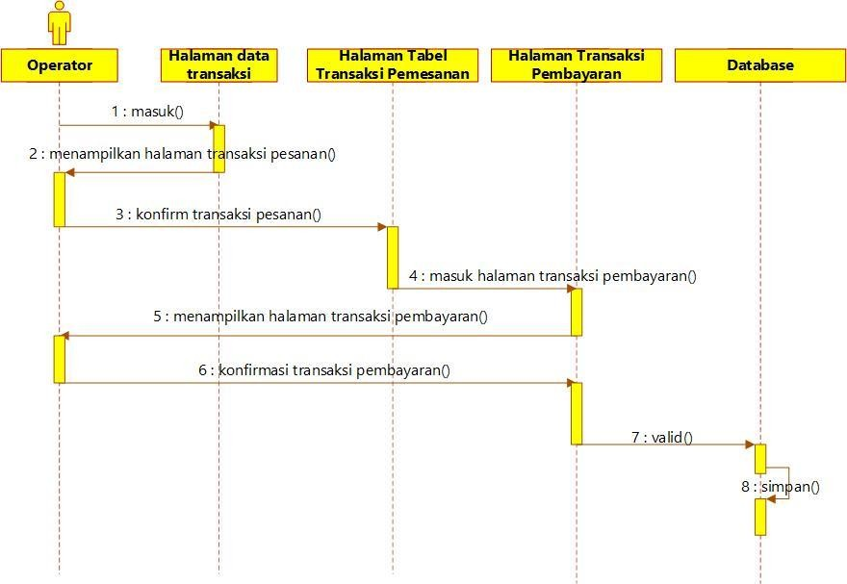

* Sequence Diagram Cek Transaksi Penjualan

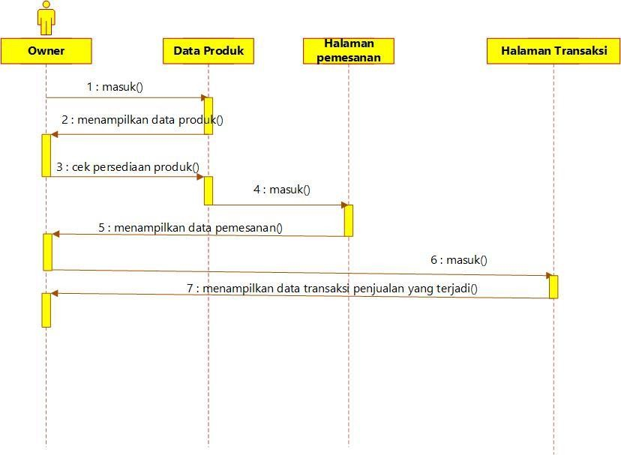

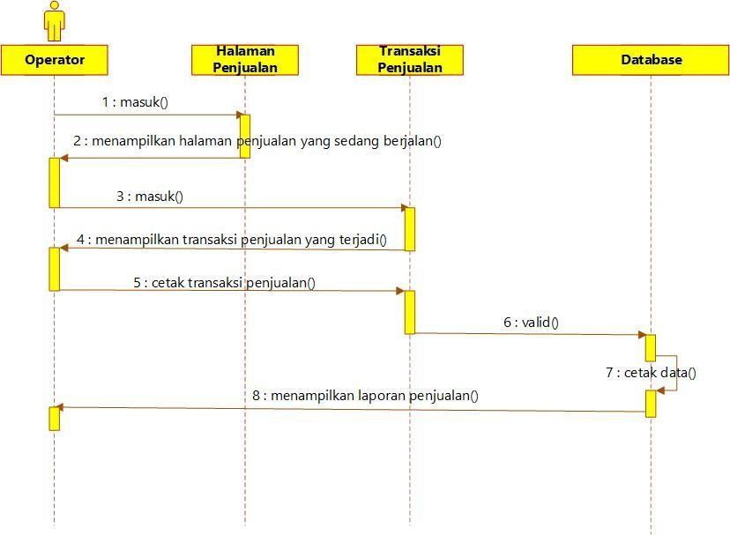

* Rancangan Antar Muka *Login* Admin

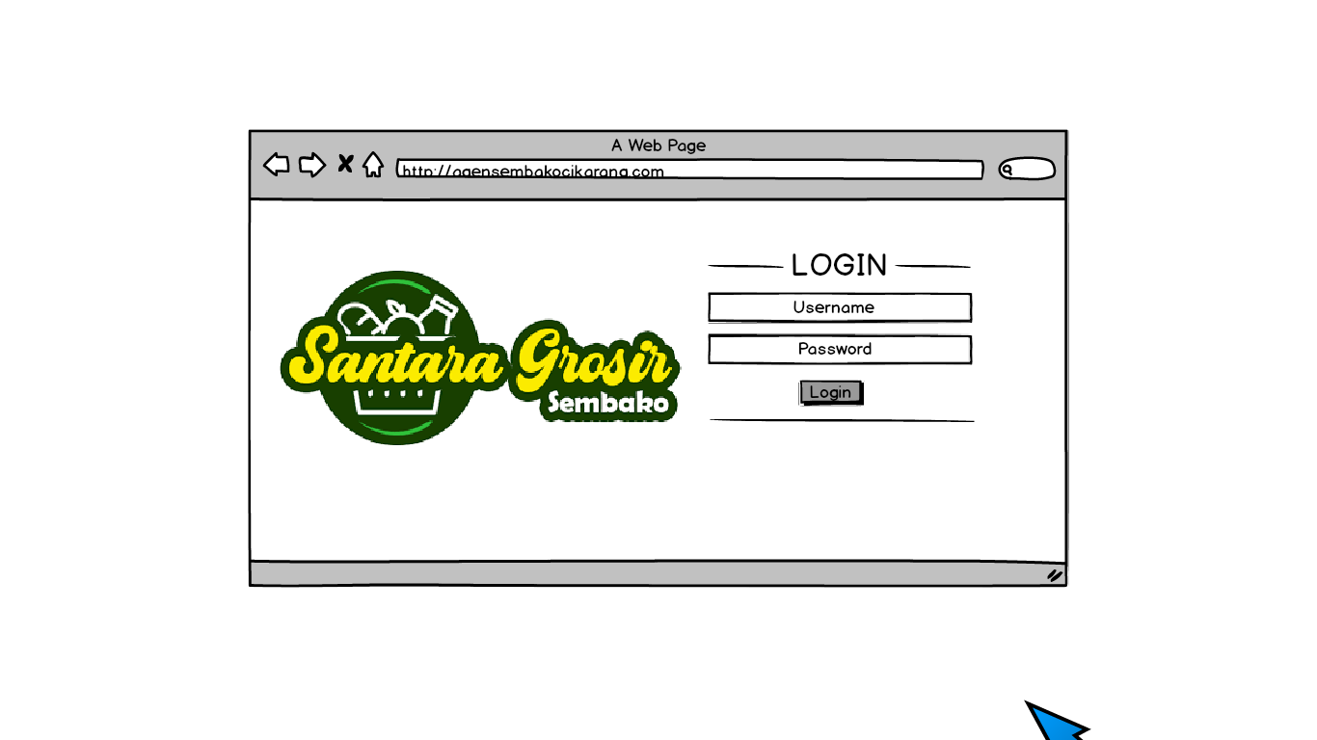

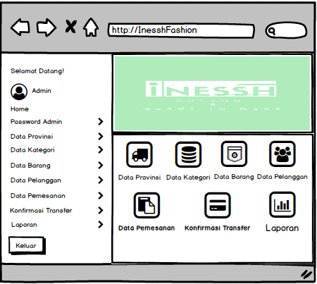

* Rancangan Antar Muka Kelola *Password* Admin

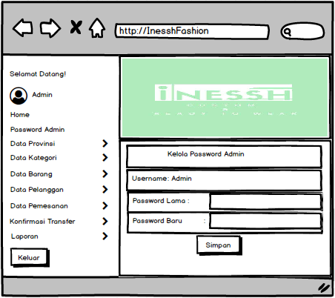

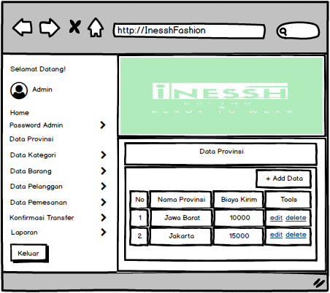

* Rancangan Antar Muka Data Kategori

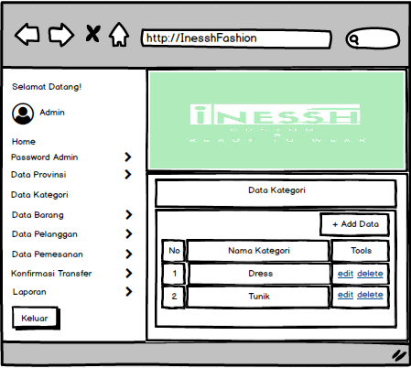

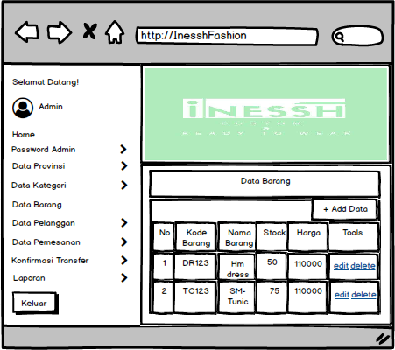



G

* Rancangan Antar Muka Data Pelanggan
* 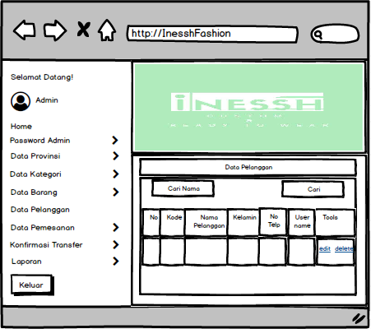

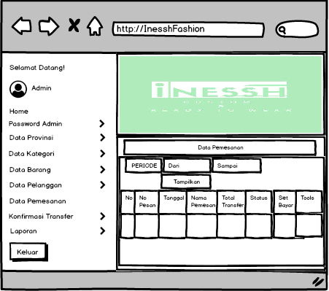

* Rancangan Antar Muka Konfirmasi Transfer
* 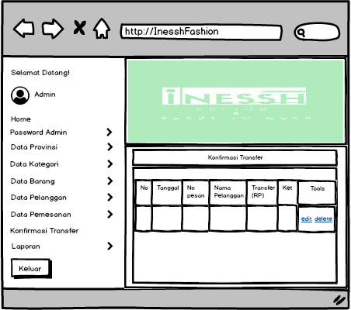



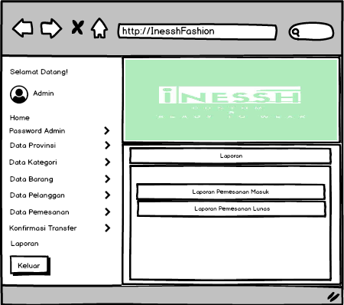-

-

-

-

* Rancangan Antar Muka Laporan Pemesanan Masuk
* 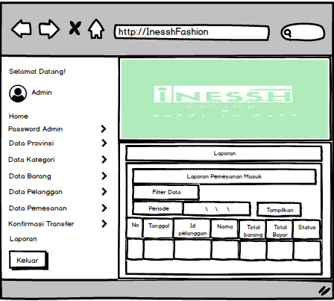

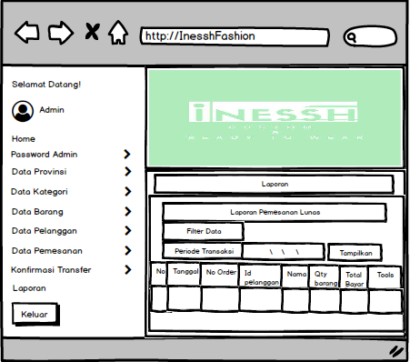

* Rancangan Antar Muka Home Member
* 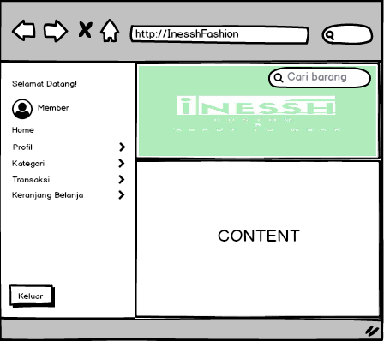-

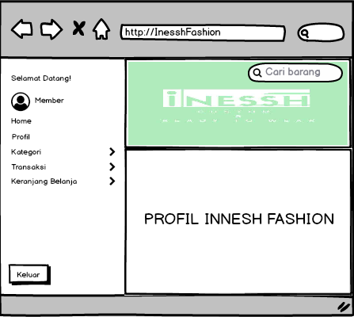

* Rancangan Antar Muka Transaksi Member

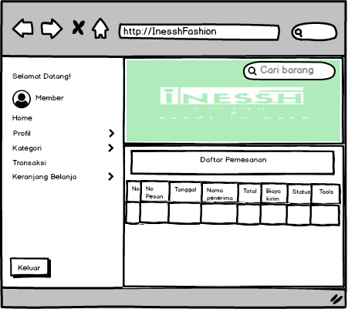

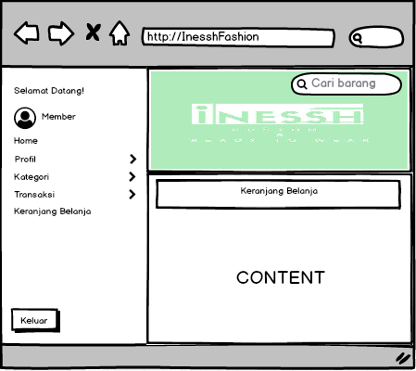

1. - Tabel File Admin

|  |  |  |  |
| --- | --- | --- | --- |
| Nama Field | Type | Size | Keterangan |
| Id | Int | 2 | primary key |
| Username | Varchar | 30 | - |
| Password | Varchar | 200 | - |

* Tabel File Barang

|  |  |  |  |
| --- | --- | --- | --- |
| Nama Field | Type | Size | Keterangan |
| kd_barang | Varchar | 5 | primary key |
| nm_barang | Varchar | 100 | - |
| harga_modal | Int | 12 | - |
| harga_jual | Int | 12 | - |
| Stok | Int | 4 | - |
| Keterangan | Text |  | - |
| file_gambar | Varchar | 100 | - |
| kd_kategori | Varchar | 4 | Foreign key |

|  |  |  |  |
| --- | --- | --- | --- |
| Nama Field | Type | Size | Keterangan |
| kd_kategori | Varchar | 5 | primary key |
| nm_kategori | Varchar | 100 | - |

* Tabel File Konfirmasi

|  |  |  |  |
| --- | --- | --- | --- |
| Nama Field | Type | Size | Keterangan |
| Id | Int | 4 | primary key |
| no_pemesanan | Varchar | 8 | - |
| nm_pelanggan | Varchar | 100 | - |
| jumlah_transfer | Int | 12 | - |
| Keterangan | Text |  | - |
| Tanggal | Date |  | - |

* Tabel File Pelanggan

|  |  |  |  |
| --- | --- | --- | --- |
| Nama Field | Type | Size | Keterangan |
| kd_pelanggan | Varchar | 5 | primary key |
| nm_pelanggan | Varchar | 100 | - |
| Kelamin | Varchar | 20 |  |
| Email | Varchar | 100 |  |
| no_telp | Varchar | 20 |  |
| Username | Varchar | 20 |  |
| Password | Varchar | 100 |  |
| tgl_daftar | Date |  |  |

* Tabel File Pemesanan

|  |  |  |  |
| --- | --- | --- | --- |
| Nama Field | Type | Size | Keterangan |
| no_pemesanan | varchar | 8 | primary key |
| kd_pelanggan | varchar | 6 | foreign key |

|  |  |  |  |
| --- | --- | --- | --- |
| tgl_pemesanan | Date |  |  |
| nama_penerima | varchar | 60 |  |
| alamat_lengkap | varchar | 200 |  |
| Kota | varchar | 100 |  |
| kode_pos | varchar | 6 |  |
| no_telp | varchar | 20 |  |
| status_bayar | varchar | 10 |  |
| no_transaksi | varchar | 10 |  |
| kd_provinsi | varchar | 10 |  |

* Tabel File Provinsi

|  |  |  |  |
| --- | --- | --- | --- |
| Nama Field | Type | Size | Keterangan |
| kd_provinsi | Varchar | 3 | primary key |
| nm_provinsi | Varchar | 100 |  |
| biaya_kirim | Int | 2 |  |

* Tabel File Keranjang Belanja

|  |  |  |  |
| --- | --- | --- | --- |
| Nama Field | Type | Size | Keterangan |
| Id | Int | 5 | primary key |
| kd_barang | Varchar | 5 | foreign key |
| Harga | Int | 12 | - |
| Jumlah | Int | 3 | - |
| Tanggal | Date |  | - |
| kd_pelanggan | Varchar | 6 | - |

* Tabel File Transaksi

|  |  |  |  |
| --- | --- | --- | --- |
| Nama Field | Type | Size | Keterangan |
| kd_pelanggan | Varchar | 10 | primary key |
| nm_barang | Varchar | 11 | - |
| Harga | Int | 100 | - |

|  |  |  |  |
| --- | --- | --- | --- |
| Jumlah | Int | 100 | - |
| Total | Int | 100 | - |
| tgl_transaksi | Date |  | - |
| kd_provinsi | Varchar | 10 | - |
| no_transaksi | Varchar | 10 | foreign key |
| nama_penerima | Varchar | 50 | - |
| alamat_lengkap | Varchar | 100 | - |
| Kota | Varchar | 20 | - |
| kode_pos | Varchar | 10 | - |
| no_telp | Varchar | 20 | - |
| status_bayar | Varchar | 10 | - |